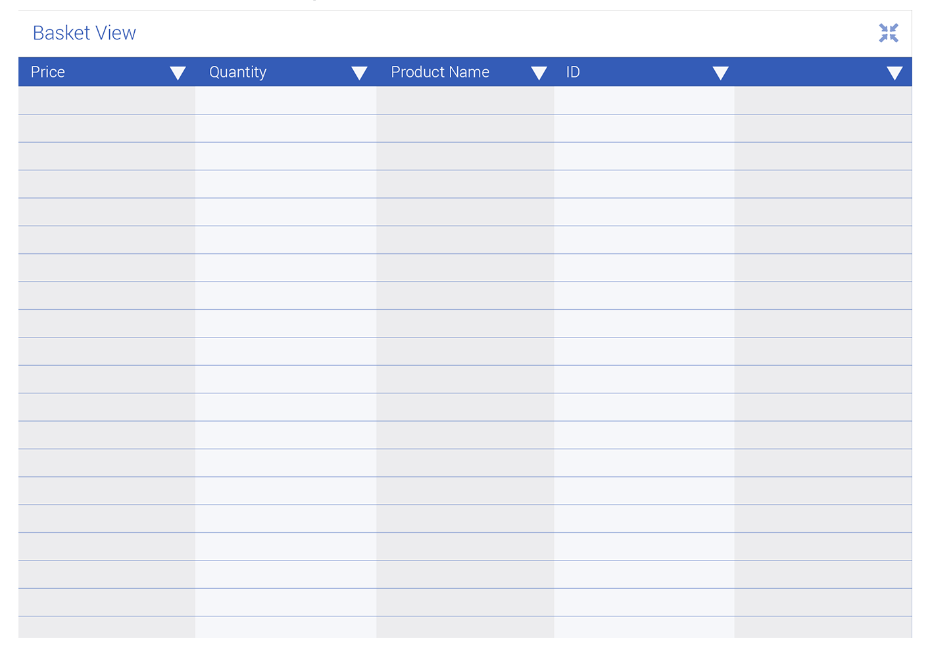

This is the detailed basket view. On this page we can see all the items that the user has collected during the game. For example, the user will be able to see the price; how many of the item they have collected; what the product is (product name) as well as the Individual identity code of the item. This will help our game because it will allow the user to view each item as they please and therefore the game will be more interactive for our user and will increase the enjoyment the user will experience.

In the example above we can see that the user has sorted the products by alphabetical referencing. This will help the user to see the list by their own preferences.

1

1

2

6

4

Parmesan Cheese

£6.04

Lima Beans

Coconut Oil

2

5

5

£7.68

£4.61

£5.50

4

2

1

Monkfish

Apple Butter

3

2.80

£7.68

£6.04

2.80

£4.61

£5.50

2

4

1

6

1

1

3

4

Coconut Oil

Parmesan Cheese

Lima Beans

Monkfish

Apple Butter

Storyboard: Basket Detailed View

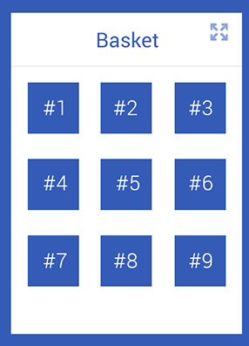

This is the mini basket view and it shows the 9 most recently collected items. The order they are in the basket is determined by the most recently collected item to the least recently collected item. This mini basket view allows the user to see which items they have collected as well as when.

If the user wants to, there is an option to maximise this display and choose sorting options for the items (shown on the previous display). This can be done by clicking the ‘maximise’ option on the top right hand side of the tab.

Storyboard: Mini Basket View

Storyboard : Main Screen

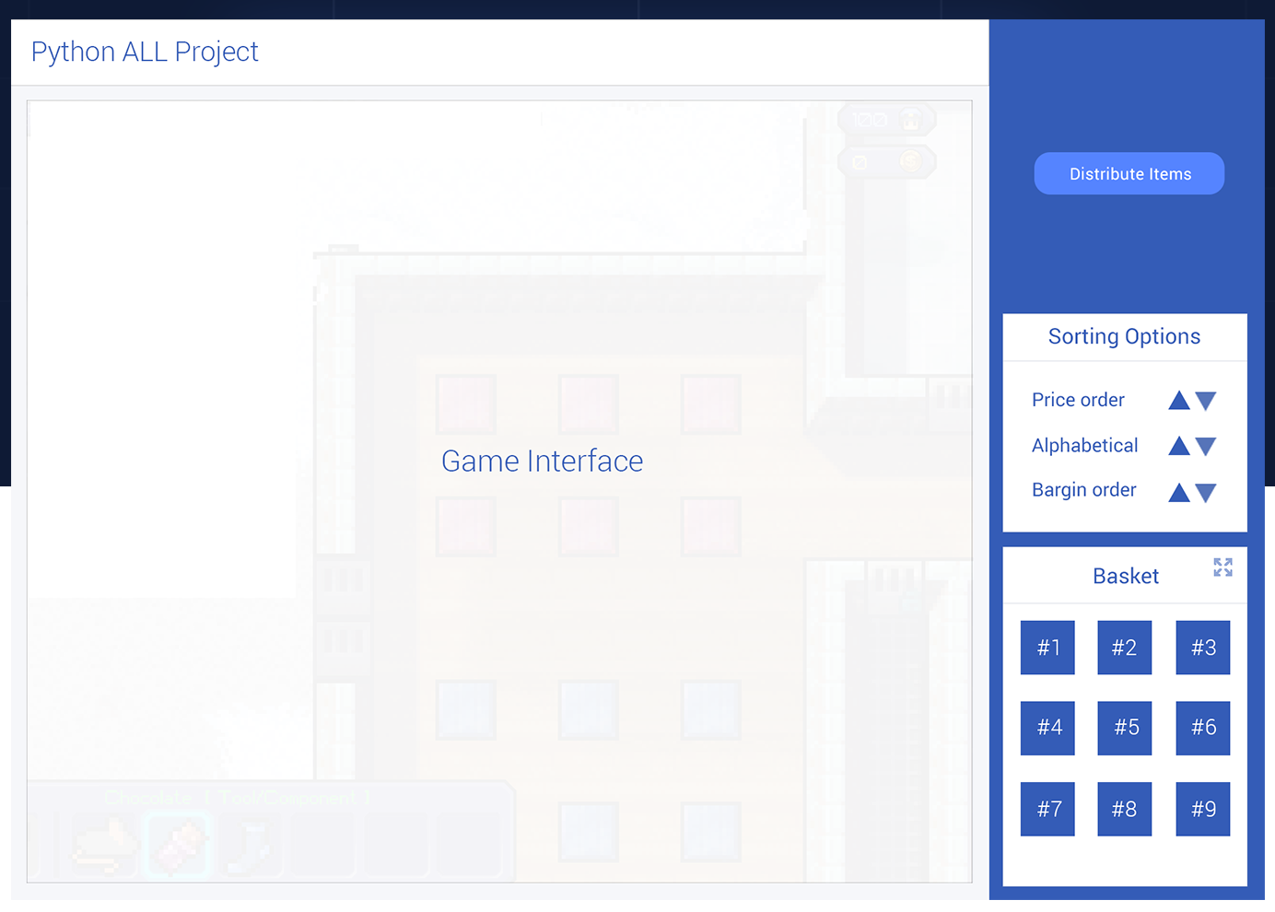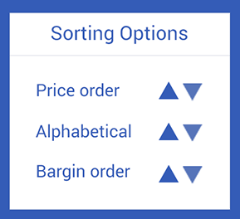

The main Screen has 3 main elements, the game map, the mini basket and the options section for the user to choose how they want to sort the items.

The main screen itself is dynamic and can be changed into different sizes if needed.

The map section of the screen is the main stage where the game will take place. The items and the character will be shown on this screen.

Our game has got three levels in it which means that the maze map will change between 3 different levels of increasing difficulty each time.

The items for the user to collect will be generated and randomly placed on the screen and the character will have to work out how to get to them through the maze.

This is the options section of the screen. This screen allows the user to customize the experience of the game. For example, this will have options for the user that will show and hide the character, change to a different character, control the speed of the character going around the shop floor / maze, change the order of the items in the basket Etc.

Storyboard : Options Section